**LAB – 2**

AIM – More Linux Commands

1) cd - Changes into the given directory

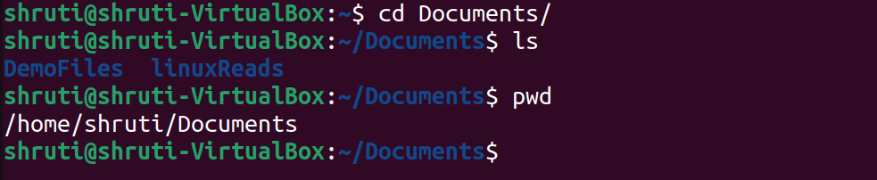

2) cmp - compare given files

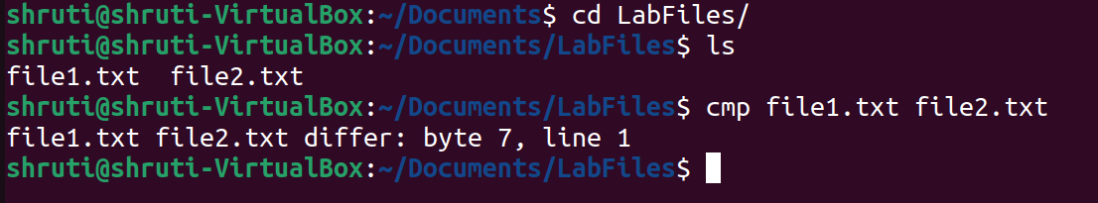

3) cat - displays the content of a file

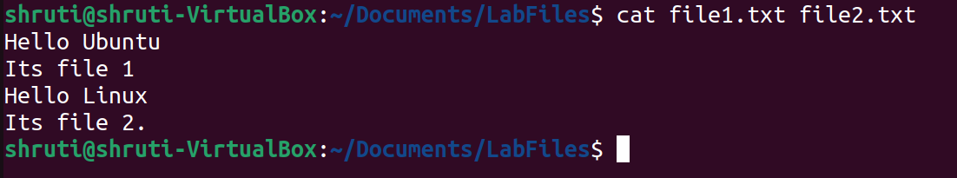

4) passwd – changes the user password

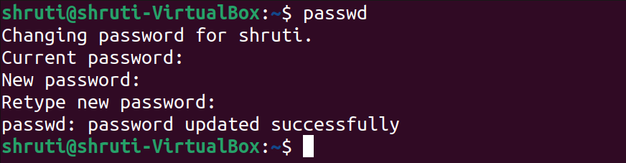

5) cal -y – displays the full year calender

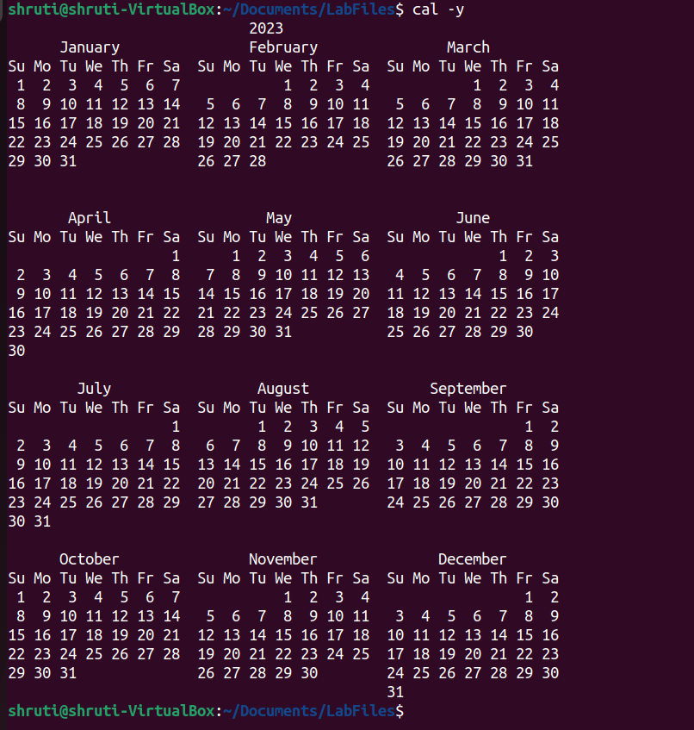

6) grep - used to search a string of characters in a file

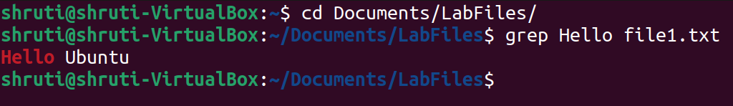

7) uname - displays the information about the system

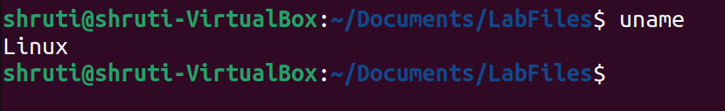

8) groups - names of the primary and supplementary groups for username

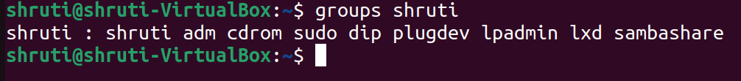

9) comm – compare command

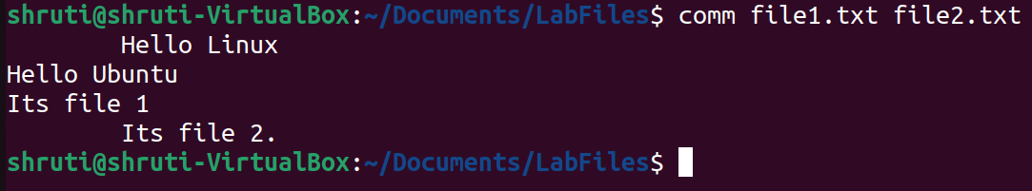

10) chmod – change access rights to files and directories

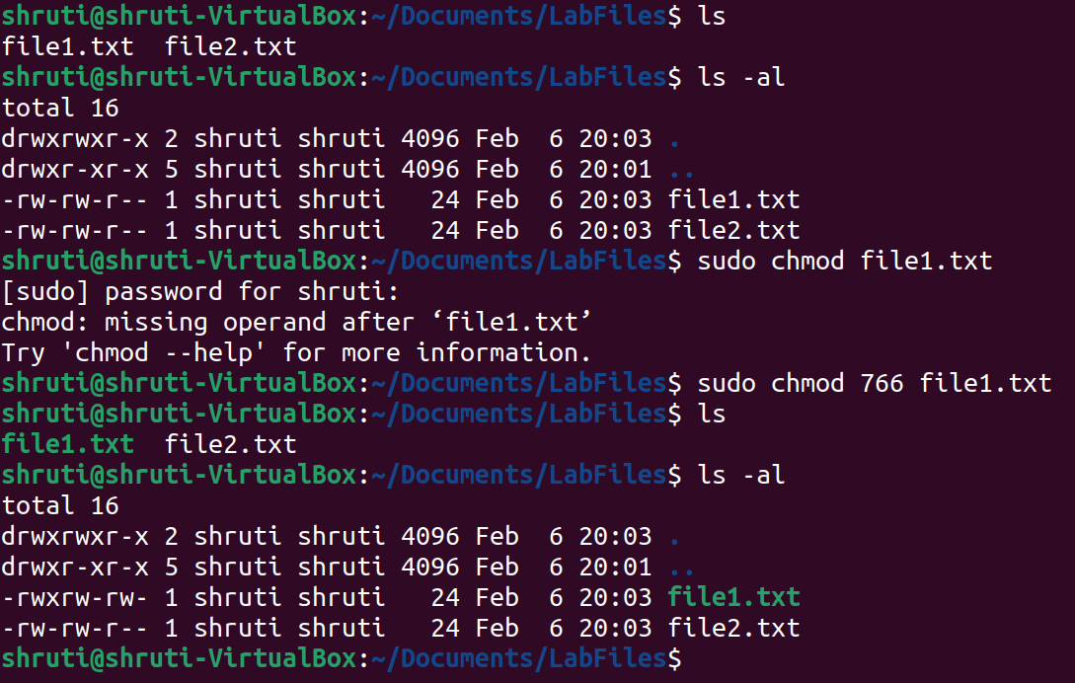

11) wc - counts and displays the number of lines, words, character and number of bytes enclosed in a file

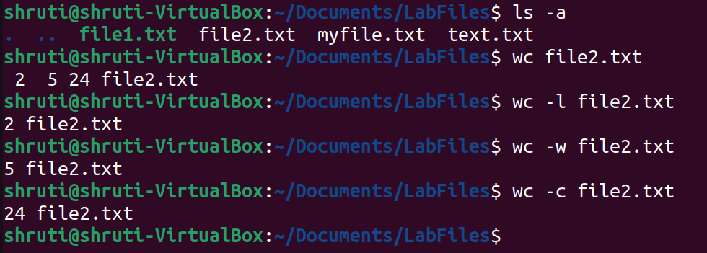

12) ps - used to report the process status

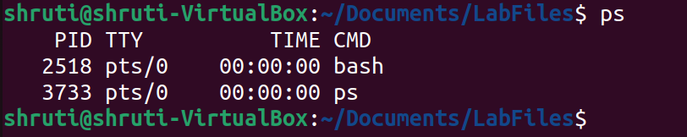

13) top – specify all processes

